Merchant Onboarding Manager


🎉 Fantastic Work on Completing Day 1 & 2!

You’re off to a strong start—and now, it’s time to dive into your custom training journey, designed to equip you with the tools, skills, and confidence to thrive as a Merchant Success Manager.

Your Role & Key Objectives

As a Merchant Success Manager, your mission is to nurture our merchants from the very beginning until they’re confidently running operations on their own.

You’re the main facilitator of their onboarding journey—from initial setup to Go Live—ensuring they’re supported every step of the way.

During the Pre-Go Live stage, your job is to make sure merchants have received everything they need—training, tools, and guidance—to go live smoothly and successfully.

What You’ll Be Mastering in the Days Ahead:

- Advanced Product Knowledge - Deep dive into StoreHub’s ecosystem so you can confidently guide merchants through every feature.

- Hardware Assessment - Test and refine your troubleshooting skills with hands-on experience.

- Buddy Sessions - Shadow and learn from Onboarding Executives, Onboarding Consultants, and fellow Merchant Success Managers to understand how real support is delivered.

- Training Assessment - Practice demoing and guiding a merchant through the BackOffice system in a live mock session with your coach.

- Welcome Call & Go Live Call Mastery - Learn how to lead both calls with clarity and confidence, followed by hands-on practice with your coach.

- Final Assessments - Your finale! You’ll be evaluated on key responsibilities—Welcome Call, Go Live process, and your BackOffice demo—to ensure you’re fully prepared to support real merchants.

Your Next 3 Days: Intense, but Worth It!
These next few days are designed to challenge and sharpen your skills—so you’re ready to make a lasting impact from day one. Let’s build the foundation for your success. You’ve got this! 💪🚀

How It Works

📌 Follow Your Schedule: Stick to the assigned time slots and topics to stay on track.

📌 Accessing Your Resources: For each topic, make sure to check out the resources provided under your role-specific tabs in the Training Wiki. These materials are your go-to guides to master the skills and knowledge required.
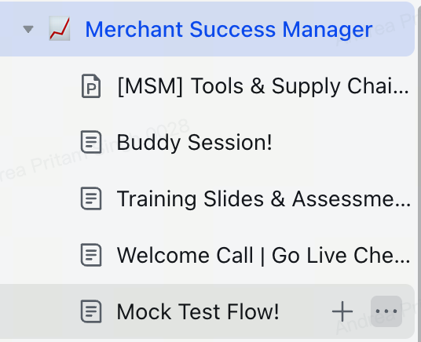

Your Schedule
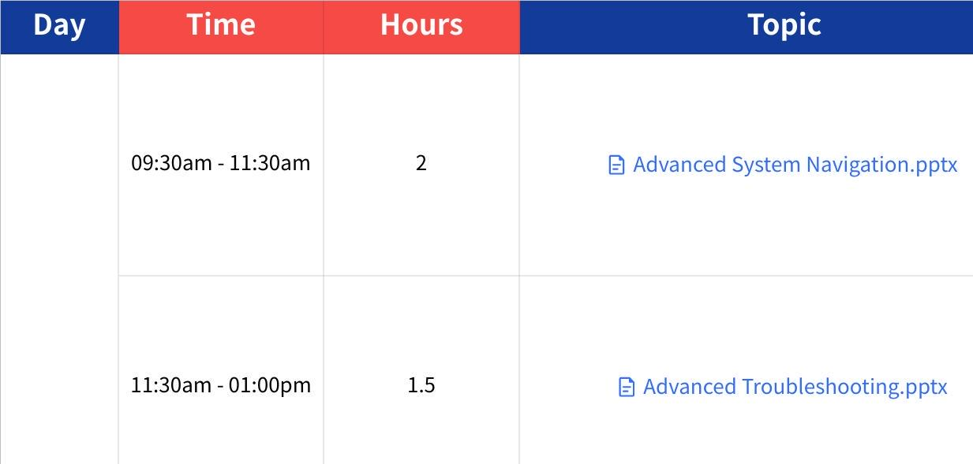
Click the image to view the sheet.

Important Note About Your Schedule 🗓️

At times, your schedule may change based on your coach’s requests. Please stay alert and keep track of any updates or adjustments made to the schedule.

Make sure to accommodate these changes promptly to stay on track with your training goals. Flexibility is key—stay adaptable, and you’ll do great! 🚀

